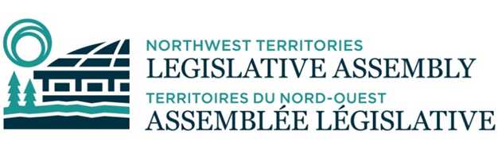

**MEETING 018-20-24 OF THE STANDING COMMITTEE OF GOVERNMENT OPERATIONS**

**WEDNESDAY, AUGUST 7, 2024 AT 9:30 A.M.**

**DET’ANCHOGH KŲ́É - EAGLE ROOM**

# **AGENDA**

1. Prayer
2. Review and Adoption of Agenda
3. Declarations of Conflict of Interest
4. In Camera Matters
   1. Bill 7: *Miscellaneous Statute Law Amendment Act*
   2. *Cannabis Legalization and Regulation Implementation Act*
   3. Government Response to Committee Report 55-19(2): Report on Bill 85
   4. Statutory Officer Annual Reports Work Plan
   5. Proposed Indigenous Employment Policy
   6. Correspondence:

2024-07-02 – Confidential Correspondence from Citizen

* 1. Committee work plan

1. New Business
2. Date and Time of Next Meetings: At the Call of the Chair
3. Adjournment