

**COMMITTEE RECORD OF PROCEEDING**

**MEETING 018-20-24 OF THE STANDING COMMITTEE OF GOVERNMENT OPERATIONS**

**WEDNESDAY, AUGUST 7, 2024 AT 9:30 A.M.**

**DET’ANCHOGH KŲ́É - EAGLE ROOM**

Chair Morse called the meeting to order at 9:31 a.m.

Committee Members in attendance: Morse, Edjericon, Reid, Hawkins, Rodgers, Weyallon-Armstrong

Regrets:

1. Prayer was conducted by MLA Edjericon
2. MLA Reid moved the adoption of the agenda as amended. Carried.
3. There were no declarations of conflicts of interest.
4. Public Matters:
   1. No Public Matters

MLA Reid moved that Committee move in-camera for the following items. Carried. Committee moved in camera at 9:33 a.m.

1. In Camera Matters
2. Debrief
3. Committee Business
4. New Business:
   1. No new Business was added.

MLA Edjericon moved that Committee conclude in-camera matters. Carried. Committee concluded in-camera matters at 11:03 a.m.

1. Date and Time of Next Meeting: At call of Chair.
2. MLA Reid moved to adjourn the meeting. Carried. The meeting was adjourned at 11:03 a.m.

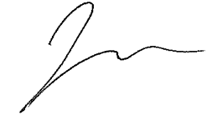

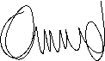

________________ ________________

Name, Chair Name, Committee Clerk